**Cubenado Assignment**

1. Create a Particle System of cubes.
2. Disperse the Cubes in a tornado
3. Have a slider to dictate the maximum amount of cubes that will be on the screen at the same time. Have a Minimum of 10 and Maximum of 10,000.
4. Have another slider to add randomness to the movement and speed of the cubes
5. Makes sure this project can run on a mobile device

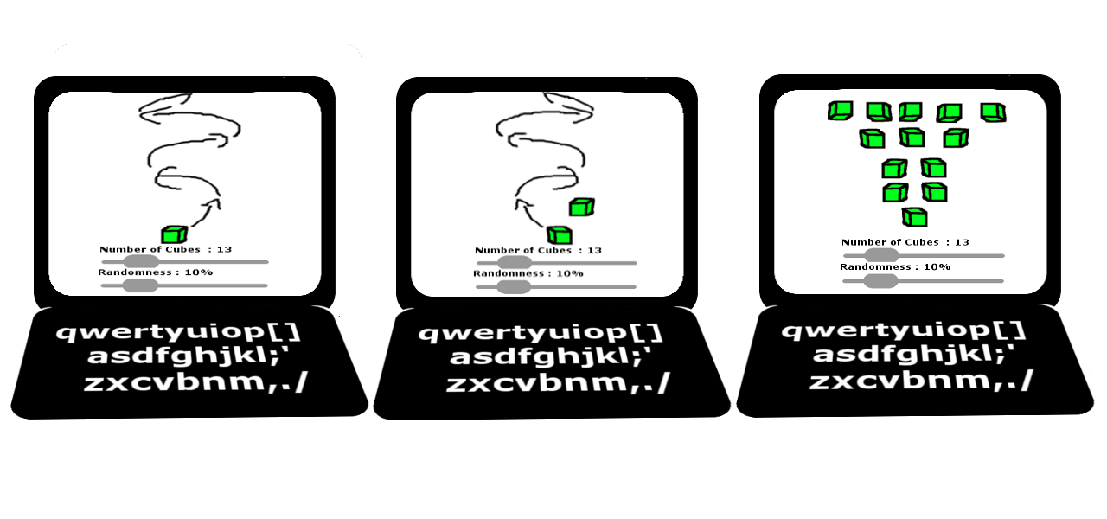

Extra Credit:

1. Add buttons to the website to change the shader used on all the cubes.

a. Implement multiple shaders like Rim Lite Shader and/or Toon Shader.

2. Create this assignment using OpenGL with no help from frameworks like THREEJS

3. Add a Gravitational force to the cubes. You can use a physics engine or using you own fake physics to simulate gravity.

*Please note that you will be asked to go over your code and we will be judging it based on cleanliness and performance.